A drop in the number of nurses caring for poorly babies is leading to higher death rates, while all patients are more likely to survive with more nurses, research has found.

Two new studies show that the number of nurses at [NHS](http://www.mirror.co.uk/all-about/nhs) bedsides in England appears to have an impact on whether patients live.

One of the studies also warned against shoring up nurse numbers with healthcare support workers.

[The Department of Health](http://www.mirror.co.uk/all-about/department-of-health) forced the National Institute for Health and Care Excellence (Nice) to stop its work into safe staffing levels last summer - although some of their recommendations on staff-patient ratios have been leaked.

The work has now shifted to NHS Improvement.

In the first of the new studies, published in the Archives of Disease in Childhood journal, experts found that one-to-one nursing for very sick babies in neonatal intensive care dropped by a third - from an average of 9% intensive care days to an average of around 6% - between 2008 and 2012.

The proportion of babies in the units who received one-to-one nursing care fell from around 39.5% to just under 36%.

The British Association of Perinatal Medicine (BAPM) recommends one-to-one nursing care for newborns in neonatal intensive care, and a ratio of one nurse for every two infants in high dependency units.

For babies in special care, the recommended ratio is one nurse to four babies yet few neonatal units meet these ratios.

* [News](http://www.mirror.co.uk/news/)
* [Politics](http://www.mirror.co.uk/all-about/politics)
* [Football](http://www.mirror.co.uk/sport/football/)
* [Sport](http://www.mirror.co.uk/sport/)
* [Celebs](http://www.mirror.co.uk/3am/)
* [TV & Film](http://www.mirror.co.uk/tv/)
* [Weird News](http://www.mirror.co.uk/news/weird-news/)

TRENDING[QUEEN'S SPEECH 2016](http://www.mirror.co.uk/all-about/queens-speech)[BEN NEEDHAM](http://www.mirror.co.uk/all-about/ben-needham)[DAVID CAMERON](http://www.mirror.co.uk/all-about/david-cameron)[INVICTUS GAMES](http://www.mirror.co.uk/all-about/invictus-games)[JEREMY CORBYN](http://www.mirror.co.uk/all-about/jeremy-corbyn)[WEATHER](http://www.mirror.co.uk/all-about/weather)

* [Technology](http://www.mirror.co.uk/tech/)
* [Money](http://www.mirror.co.uk/money/)
* [Travel](http://www.mirror.co.uk/lifestyle/travel/)
* [Fashion](http://www.mirror.co.uk/3am/style/)
* [Mums](http://www.mirror.co.uk/lifestyle/family/)
* [**Home**](http://www.mirror.co.uk/)
* [**News**](http://www.mirror.co.uk/news/)
* [**UK News**](http://www.mirror.co.uk/news/uk-news/)
* [**Babies**](http://www.mirror.co.uk/all-about/babies)

Drop in neonatal intensive care nurses 'leading to higher death rates'

* 23:30, 9 FEB 2016
* **UPDATED**00:00, 10 FEB 2016
* **BY** JANE KIRBY

Experts have linked a drop in one-to-one nursing for very sick babies with a monthly increase in baby death rate of 0.6 per 100 infants

* **115**SHARES

* [**1**COMMENT](http://www.mirror.co.uk/news/uk-news/drop-neonatal-intensive-care-nurses-7339659#comments-section)

Getty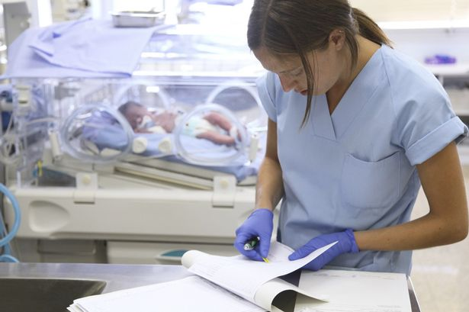

Nursing: One-to-one care for babies in neonatal intensive care has dropped by a third

A drop in the number of nurses caring for poorly babies is leading to higher death rates, while all patients are more likely to survive with more nurses, research has found.

Two new studies show that the number of nurses at [NHS](http://www.mirror.co.uk/all-about/nhs) bedsides in England appears to have an impact on whether patients live.

One of the studies also warned against shoring up nurse numbers with healthcare support workers.

[The Department of Health](http://www.mirror.co.uk/all-about/department-of-health) forced the National Institute for Health and Care Excellence (Nice) to stop its work into safe staffing levels last summer - although some of their recommendations on staff-patient ratios have been leaked.

The work has now shifted to NHS Improvement.

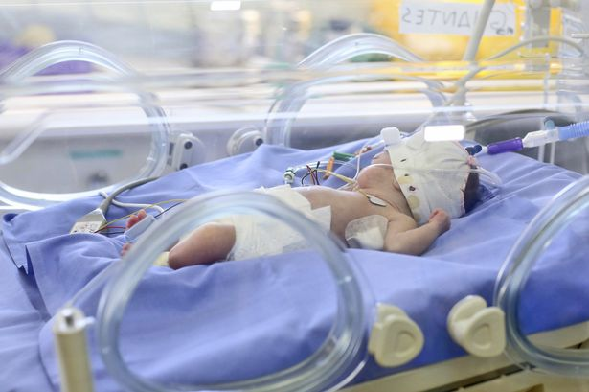Study: Babies receiving one-to-one care fell from 39.5 to 36 per cent

In the first of the new studies, published in the Archives of Disease in Childhood journal, experts found that one-to-one nursing for very sick babies in neonatal intensive care dropped by a third - from an average of 9% intensive care days to an average of around 6% - between 2008 and 2012.

The proportion of babies in the units who received one-to-one nursing care fell from around 39.5% to just under 36%.

**Read more:** [Number of people unhappy with NHS at highest level for 30 years](http://www.mirror.co.uk/news/uk-news/number-people-unhappy-nhs-suffers-7335360)

The British Association of Perinatal Medicine (BAPM) recommends one-to-one nursing care for newborns in neonatal intensive care, and a ratio of one nurse for every two infants in high dependency units.

For babies in special care, the recommended ratio is one nurse to four babies yet few neonatal units meet these ratios.

PA

Study: University College Hospital London

Experts from Imperial College London, the University of Leicester, University College London and Warwick University extracted monthly data for England from the National Neonatal Research Database on babies admitted to 43 intensive care units between 2008 and 2012.   
During this period, an average of 4.5 infants out of every 100 (4.5%) in intensive care died every month.

Calculations showed that a 10% drop in the proportion of intensive care days on which one-to-one nursing care was provided was linked with a monthly increase in baby death rates of 0.6 per 100 infants (0.6%) in intensive care.

The authors stressed the study was observational and did not prove that low nursing ratios were to blame.

But they said: "Our study suggests that decreases in the provision of one-to-one nursing in tertiary-level neonatal intensive care units increase the in-hospital mortality rate."

In an editorial, Dr Alan Fenton, University of Leeds pediatric expert Sue Turrill and Caroline Davey, the chief executive of premature and sick baby charity Bliss, said more than 90,000 babies were admitted to neonatal units in England, Scotland and Wales in 2014. Just under 14% of the care days these babies received was in intensive care.

While Health Secretary [Jeremy Hunt](http://www.mirror.co.uk/all-about/jeremy-hunt) has announced plans to cut the rate of neonatal deaths, "the announcement has so far singularly failed to acknowledge the importance of improving staffing levels in order to reduce neonatal deaths, despite consistent information from neonatal professionals," they said.

Ms Davey added: "The Government and NHS decision makers have so far failed to take the necessary action to address these staffing shortfalls, which we have known about for many years.

"It is now absolutely vital that they focus on achieving the national standards. Having a baby on an intensive care unit is already an incredibly stressful situation - parents shouldn't also have to worry if there are enough nurses to provide the right care for their baby."